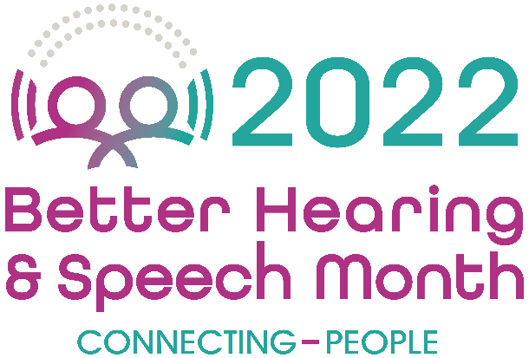

FOR IMMEDIATE RELEASE Contact: Name
Phone Number
Email

(City)-Based Expert Encourages Action on Hearing Loss This May for Better Hearing and Speech Month

48 Million Americans Experience Hearing Loss

(City, State – Date) May is national Better Hearing and Speech Month (BHSM), and (city)-based audiologist (full name, place of employment) is using this important observance to encourage residents to have their hearing tested—and take action if they have hearing loss.

“Hearing loss is one of the most common, chronic conditions that Americans experience,” explains (last name). “Yet many people wait years or even decades to take any action on their hearing loss—if they ever do. This is true even as we have so many intervention and treatment options that help people to communicate more effectively. During May, we want to inform the public how and where they can connect with help for hearing and related conditions—and why it's important that they do so.”

Hearing Loss Can Happen at Any Age

Although many people know that you can be born deaf and/or hard of hearing—and that hearing loss is relatively common in older adults—it’s important to understand that hearing loss can occur at any point across the lifespan. Roughly 15% of school-aged children ages 6–19 have hearing loss, according to the U.S. Centers for Disease Control and Prevention. In the U.S. workplace, about 22 million workers (17%) are exposed to hazardous noise each year—putting their hearing at risk.

Hearing loss may be due to exposure to excessive noise (e.g., from noisy occupations or leisure activities), ear infections, and even certain medications or medical treatments—among other reasons. Yet, many people routinely ignore their hearing health. According to a 2021 national poll from the American Speech-Language-Hearing Association (ASHA) and YouGov, only 2 in 10 adults (20%) have had a hearing test in the past 5 years, compared with roughly 6 in 10 (61%) who have had their vision tested.

“Most people underestimate their degree of hearing loss—as well as the impact it’s having on their lives,” (last name) explained. “Even a so-called mild hearing loss that goes undetected can put a child one or more grade levels behind in school. For adults, untreated hearing loss is increasingly connected to cognitive decline and earlier onset of dementia. So, the benefits of treatment are clear and convincing.”

(Last name) stresses that this is why it’s critical for all people to take measures to protect their hearing—for example, limiting their time in noisy spaces and wearing hearing protection at loud events—as well as to stay attuned to the signs of hearing loss. These signs aren’t always obvious and may include having difficulty following conversations, having trouble hearing on the phone, perceiving that people frequently sound like they’re mumbling, or having difficulty understanding what children are saying.

Seeking Help

As a first step, (last name) recommends that anyone with concerns about their or a loved one’s hearing get a hearing evaluation from a certified audiologist. Although treatment isn’t always covered by insurance, an evaluation generally is (note that a referral to an audiologist may be required). This is an important step—even for those who don’t think they can afford hearing aids. Hearing aids are not the only treatment option—and audiologists can also discuss other options based on a person’s listening needs and budget.

Audiologists can also help people who have ringing in the ears (called tinnitus), which can be very disruptive to a person’s life—and even impact their mental health. Audiologists can also help people who have dizziness and balance issues, which may originate from a problem in the inner ear. A balance problem can increase a person’s risk of falling, which is a leading cause of injury among older adults.

To learn more, and to find a certified audiologist, visit www.asha.org/public or www.ActNowonHearing.com. To schedule an evaluation with (last name office or clinic name), (visit website or provide contact information).

###

