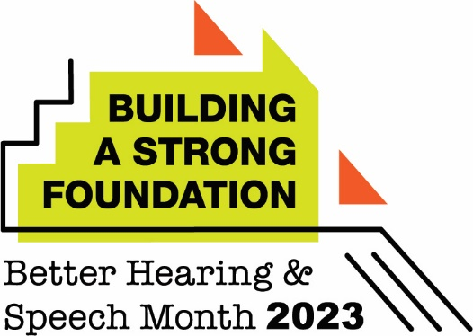

(City) Hearing Expert Urges Residents to Act Now on Their Hearing Loss

May Is Better Hearing and Speech Month

(City, State – May 1, 2023) With approximately 15% of American adults reporting difficulty hearing, (city)-based audiologist (name, credentials, place of employment) is encouraging people to learn the signs of hearing loss—and to seek care. This is a timely message, as May is recognized nationally as Better Hearing and Speech Month.

“Our hearing is key to so many aspects of our lives, but it’s something that many people undervalue until we are having severe hearing difficulties,” said (last name). “Even then, some of us typically wait years to receive treatment, if ever. This is despite the fact that audiologists can help people in many different ways.”

(Last name) continued: “Hearing loss is much more than a simple nuisance. Left unaddressed, it can affect us in a variety of ways, from increased risk for physical danger such as falling or missing warning signals like a fire alarm; to mental health problems, including social isolation and depression; to cognitive decline, including earlier onset of dementia. Our personal relationships, career success, and healthcare costs can be affected as well.”

Signs of hearing loss in adults include the following:

- Difficulty following conversations
- Difficulty hearing in noisy environments
- Hearing ringing, roaring, or beeping in one or both ears
- Failure to respond to spoken words
- Muffled hearing
- Constant frustration hearing speech and other sounds
- Avoidance of conversation

As a first step, (last name) urges anyone concerned about their hearing (or that of a loved one) to seek a hearing evaluation from a certified audiologist. Private insurance, Medicaid, and Medicare generally cover evaluations. People can take this step even if they think they can’t afford hearing aids or other hearing services. Audiologists can advise people on ways to make hearing aids more affordable, and various organizations offer financial assistance.

Aside from hearing aids, audiologists can also identify other ways to improve a person’s listening and communication skills. They can also help families support loved ones with hearing loss.

(City) residents who would like to receive a hearing evaluation can contact (office phone number, website) to make an appointment. Learn more about hearing loss at www.asha.org/public or www.ActNowonHearing.com.

###

