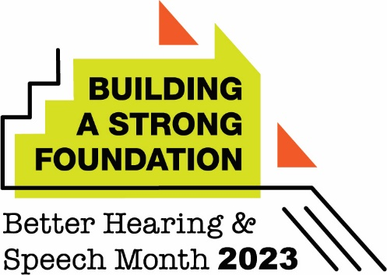

Speech and Language Disorders Common in Children, But Families Often Don’t Know the Early Signs

(City) Therapist Urges Families to Seek Help Early If They Have Concerns

(City, State – May X, 2023) As the nation recognizes Better Hearing and Speech Month this May, (city)-based speech-language pathologist (full name, credentials) encourages families to learn the signs of communication disorders.

Eleven percent of children 3–6 years of age experience a voice, speech, language, or swallowing disorder. Yet, many families do not know the early signs to look for—a factor that can result in delayed care.

Among children and young adults 6–21 years of age, speech and language disorders are one of the most common disabilities for which students receive special education services in schools through the Individuals With Disabilities Education Act. Unaddressed, speech and language disorders can affect a child’s success academically and socially.

“If families are worried about their child’s communication skills, speech-language pathologists can provide life-changing intervention that can help children develop and thrive in school and life,” said (last name). “Speech-language pathologists work in early intervention programs, private practices, schools, and health care facilities. Families can reach out to them to have their child evaluated by contacting their local school system or a private practice or clinic.”

New data from the American Speech-Language-Hearing Association (ASHA) show that lack of awareness about the signs of communication disorders is the leading factor that prevents families from taking action on these disorders in young children, according to speech-language pathologists nationwide.

“It’s so important that parents and caregivers know the warning signs and are aware of the benefits of timely intervention,” added (last name). “Many communication disorders can be reversed or even prevented. While working with a speech-language pathologist can benefit a child at any age, intervention and treatment services often take less time and are most effective if they happen when the signs of a disorder first appear.”

(Last name) shares some of the common signs of these disorders below:

Signs of a Speech Sound Disorder
- Says p, b, m, h, and w incorrectly in words (2–3 years)
- Says k, g, f, t, d, and n incorrectly in words (3–4 years)
- Produces speech that is unclear, even to familiar people (2–3 years)

Signs of a Language Disorder
- Does not smile or interact with others (birth and older)
- Does not babble (4–6 months)
- Makes only a few sounds or gestures, like reaching (7–9 months)
- Does not understand what others say (10 months – 2 years)
- Says only a few words (19 months – 2 years)
- Does not put words together to make sentences (19 months – 3 years)
- Speaks using words that are not easily understood by others (3–4 years)
- Has trouble with early reading skills, like pretending to read or finding the front of a book (4–5 years)

Signs of Stuttering (Disfluency)
- Repeats the first sounds of words—“b-b-b-ball” for “ball”
- Stretches sounds out—“ffffff-farm” for “farm”
- Shows frustration when trying to get words out

Signs of a Voice Disorder
- Loss of voice
- Uses a hoarse or breathy voice
- Speaks with strain and effort

For more information, (last name) advises that families visit www.IdentifytheSigns.org. Families who would like to have their child evaluated can contact (office, clinic, or EI program information).

###

