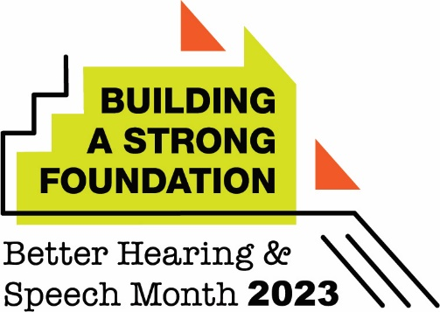

May 1, 2023

Dear Families:

My name is (first and last name, credentials), and I’m the educational audiologist at (school name).

Roughly 15% of children 6–19 years of age have some degree of hearing loss. Unidentified hearing loss can significantly affect a student’s academic and social success. May is Better Hearing and Speech Month, the perfect time to familiarize yourself with the signs of hearing loss in children. These include

- difficulty following or understanding instructions;
- feeling exhausted at the end of the school day;
- experiencing academic, behavioral, or social difficulties at school; and
- using increased volume on the TV or other listening devices.

If you have concerns about your child’s hearing, I encourage you to reach out to (insert counselor, principal, or appropriate school contact name), who can facilitate scheduling a hearing test through the school district—or to make an appointment with a private audiologist for a hearing evaluation.

I also want to mention the importance of hearing protection, particularly at this time of year. Summer is typically a season of loud activities: fireworks displays, sporting events, and concerts/festivals, to name a few. Summer may also mean more free time for children to use technology devices such as gaming systems, tablets, and smartphones—often with earbuds or headphones. Many kids crank the volume on these devices to dangerously loud volumes, putting their hearing at risk.

You can prevent damage to your children’s hearing by encouraging and enforcing some simple steps, including the following behaviors:

- Practice “safe listening” when using technology. It’s critical that you keep the volume at 50% or less. Also, take listening breaks every hour (even for just a few minutes).
- Stay away from the sources of loud noise at events. These sources include speakers, a stage, or a fireworks launch site. Aim to keep a distance of at least 500 feet.
- Wear earplugs at noisy events or while participating in noisy hobbies like playing an instrument. Consider using musician’s earplugs—a special kind specifically designed to protect your ears while still allowing you to enjoy music at safe levels.

I wish you a happy Better Hearing and Speech Month—and a fun, relaxing, and safe summer!

Best wishes,

(Insert signature)

